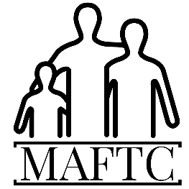
MidAmerica Family Treatment Center, LLC
4031 Central Street, Kansas City, Missouri 64111
maftc.kc@gmail.com, (913) 626-1018

Teletherapy Informed Consent
1) “Teletherapy” includes consultation, treatment, emails, telephone conversations, Skype, Face Time and other medical information platforms using interactive audio, video, or data communications. 2) Teletherapy occurs in the states of Kansas and Missouri and is governed by the laws of those states where the therapist is licensed. 3) The laws that protect the confidentiality of your information also apply to Teletherapy. Unless we explicitly agree otherwise, our Teletherapy exchange is confidential. I understand that the therapist will not include others in the session or have others in the room unless agreed upon (this would only pertain to students who are involved in internships). The parent or guardian agrees that to remain in the room and near the computer screen if the child is too young to be left alone with the technology. 4) I accepts that Teletherapy does not provide emergency services. If I am experiencing an emergency situation, I understand that I can call 911 or proceed to the nearest hospital emergency for help. 5) In the event that our Teletherapy is not in my best interest, my therapist will explain that to me and suggest some alternative options better suited to my need (though we will continue with Teletherapy through the Corona Virus - 19 pandemic). 6) I understand that there are risks and consequences from Teletherapy, including but not limited to, the possibility, despite reasonable efforts on the part of my therapist, that the transmission of my information could be disrupted or distorted by technical failures: the transmission of my information could be interrupted by unauthorized persons. I am responsible for information security on my computer.
Effective January 2021

